Course Number: | CRN 11647 CRIM 315.001 (Spring 2017)
Course Title: | Crime Control Strategies
Instructor Name: | (Dr.) Sheri Jenkins Keenan, Ph.D.
Voice Mail: | (812) 228-5138
Email Address: | skeenan@usi.edu
Office Hours:  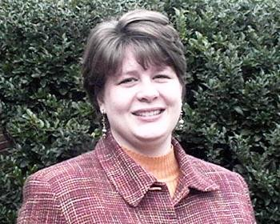 | Monday 7:00 a.m. – 9:00 a.m.  Wednesday 7:00 a.m. – 9:00 a.m.  Central Time  The Professor’s preferred methods of contact is via email, skeenan@usi.edu. Emails will be returned within 24 hours
Office Location: | Liberal Arts Center 3022
Credit Hours: | 3
Course Meeting Days: | Monday/Wednesday/Friday
Course Meeting Times: | 12:00 p.m. – 12:50 p.m.
Course Meeting Place: | Liberal Arts Center 2003
Prerequisite(s): | Two of the following CJS courses: CRIM 234, CRIM 244, POLS 208*, SOC 225, CRIM 254*.
Textbook:   | Required Readings:  - Hoover, Larry T. (2014). Police Crime Control Strategies. New York: Delmar, Cengage Learning. ISBN: 978-1133-69162-4  - Jenkins, Michael J. & DeCarlo, John. (2015). Police Leaders in the New Community Problem-Solving Era. Durham, North Carolina: Carolina Academic Press ISBN: 978-1-61163-590-4  - Anand, Anil. (2016). Mending Broken Fences Policing; An Alternative Model for Policy Management. Lulu Publishing Services. ISBN: 978-1-4834-4502-1  - Jurkanin, Thomas J., Hoover, Larry T., & Sergevnin, Vladimir A. (2007) Improving Police Response to Persons with Mental Illness A Progressive Approach. Springfield, IL. ISBN: 978-0-938-07778-5
Course Description: | An intensive, small-group discussion of recent, provocative books on the topic of crime control strategies.
Course Learning Outcomes: | Upon completing this course, the student should be able to provide an overview of the various police crime control strategies; hot spot saturation, broken windows enforcement, community policing, problem-oriented policing, crime-specific intervention, and Compstat, to include critically examining their strengths and weaknesses.
Program Learning Outcomes: | - Students will be critical and creative thinkers who can communicate effectively in oral and written form.  - Students will develop theoretical understanding of crime and criminal justice systems and will be able to apply such theories to daily experience.  - Students will fain an understanding of social problems, human diversity issues, social behavior, and social policy related to criminal justice.  - Students will have a comprehensive knowledge of all four basic areas of the field: Criminology, Policing, Courts and Law, and Corrections.  - Students will have an understanding of the research process and date analysis techniques appropriate to undergraduates and the field of criminal justice.  - Students will employ ethical perspectives and judgements in applying criminal justice knowledge.
Teaching Strategies: | Discussion, Lecture, Audio-Visuals, Demonstrations, and Return Demonstrations
Evaluation: | Class Participation (38 class meetings @ 2 pts. each) 76 points  Homework (15 @ 20 pts. each) 300 points  Critical Book Review(s) (3 @ 100 pts. each) 300 points  Mid-Term 100 points  Final Comprehensive Exam 200 points
Grading Scale:  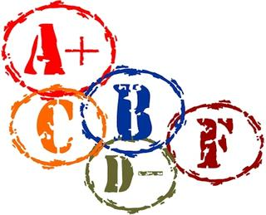 | 878 – 976 A  780 – 877 B  683 – 779 C  585 – 682 D  000 – 584 F
Attendance: | 100% attendance is expected.
Class Participation Point(s):   | There are thirty-eight (38) class meeting(s) in the Spring 2017 semester. Each class meeting time is worth 2 points. Students who show up late, leave early, are absent, regardless of reason, excused or unexcused, and who do not bring their course material(s) to class will lose their points for that class meeting. These are not simply attendance points, but participation points. You cannot participate if you are not present or if you do not bring the necessary materials to class. NO EXCEPTIONS.
Homework(s): | There are fifteen (15) home works. Homeworks are worth 20 points each for a total of 300 points. It is the responsibility of the student to check blackboard for due dates.
Critical Book Review(s):   | The Critical Book Review Assignment should be submitted on blackboard no later than:  Sunday, February 5, 2017  Sunday, March 19, 2017  Sunday, April 23, 2017  The critical book review is a description, critical analysis, and an evaluation on the quality, meaning, and significance of a book, not a retelling. It should focus on the book's purpose, content, and authority. A critical book review is not a book report or a summary. It is a reaction paper in which strengths and weaknesses of the material are analyzed. It should include a statement of what the author has tried to do, evaluate how well, in the opinion of the reviewer, the author has succeeded, and presents evidence to support this evaluation. Please see blackboard for further guidance.
Make-Up Policy: | Students are given one full week on every assignment and on the Research Writing Assignment multiple weeks to complete the assignment. Therefore, late work will NOT be accepted.  If you foresee a problem, please make sure that assignment(s) are turned in prior to the deadline. This is your responsibility as the student; NOT the professors. Assignments will NOT be accepted via email. Assignments should be submitted on blackboard only.
Students with Disabilities:   | If you have a disability for which you may require academic accommodations for this class, please register with Disability Resources (DR) as soon as possible. Students who have an accommodation letter from DR are encouraged to meet privately with course faculty to discuss the provisions of those accommodations as early in the semester as possible. To qualify for accommodation assistance, students must first register to use the disability resources in DR, Science Center Rm. 2206, 812-464-1961, www.usi.edu/disabilities. To help ensure that accommodations will be available when needed, students are encouraged to meet with course faculty at least 7 days prior to the actual need for the accommodation. However, if you will be in an internship, field, clinical, student teaching, or other off-campus setting this semester please note that approved academic accommodations may not apply. Please contact Disability Resources as soon as possible to discuss accommodations needed for access while in this setting.
USI Title IX Sexual Misconduct Policy: | USI does not tolerate acts of sexual misconduct, including sexual harassment and all forms of sexual violence. If you have experienced sexual misconduct, or know someone who has, the University can help. It is important to know that federal regulations and University policy require faculty to promptly report incidences of potential sexual misconduct known to them to the Title IX Coordinator to ensure that appropriate measures are taken and resources are made available. The University will work with you to protect your privacy by sharing information with only those who need to know to ensure we can respond and assist. If you are seeking help and would like to speak to someone confidentially, you can make an appointment with a counselor in the University Counseling Center. Find more information about sexual violence, including campus and community resources at www.usi.edu/stopsexualassault.
Classroom Decorum:  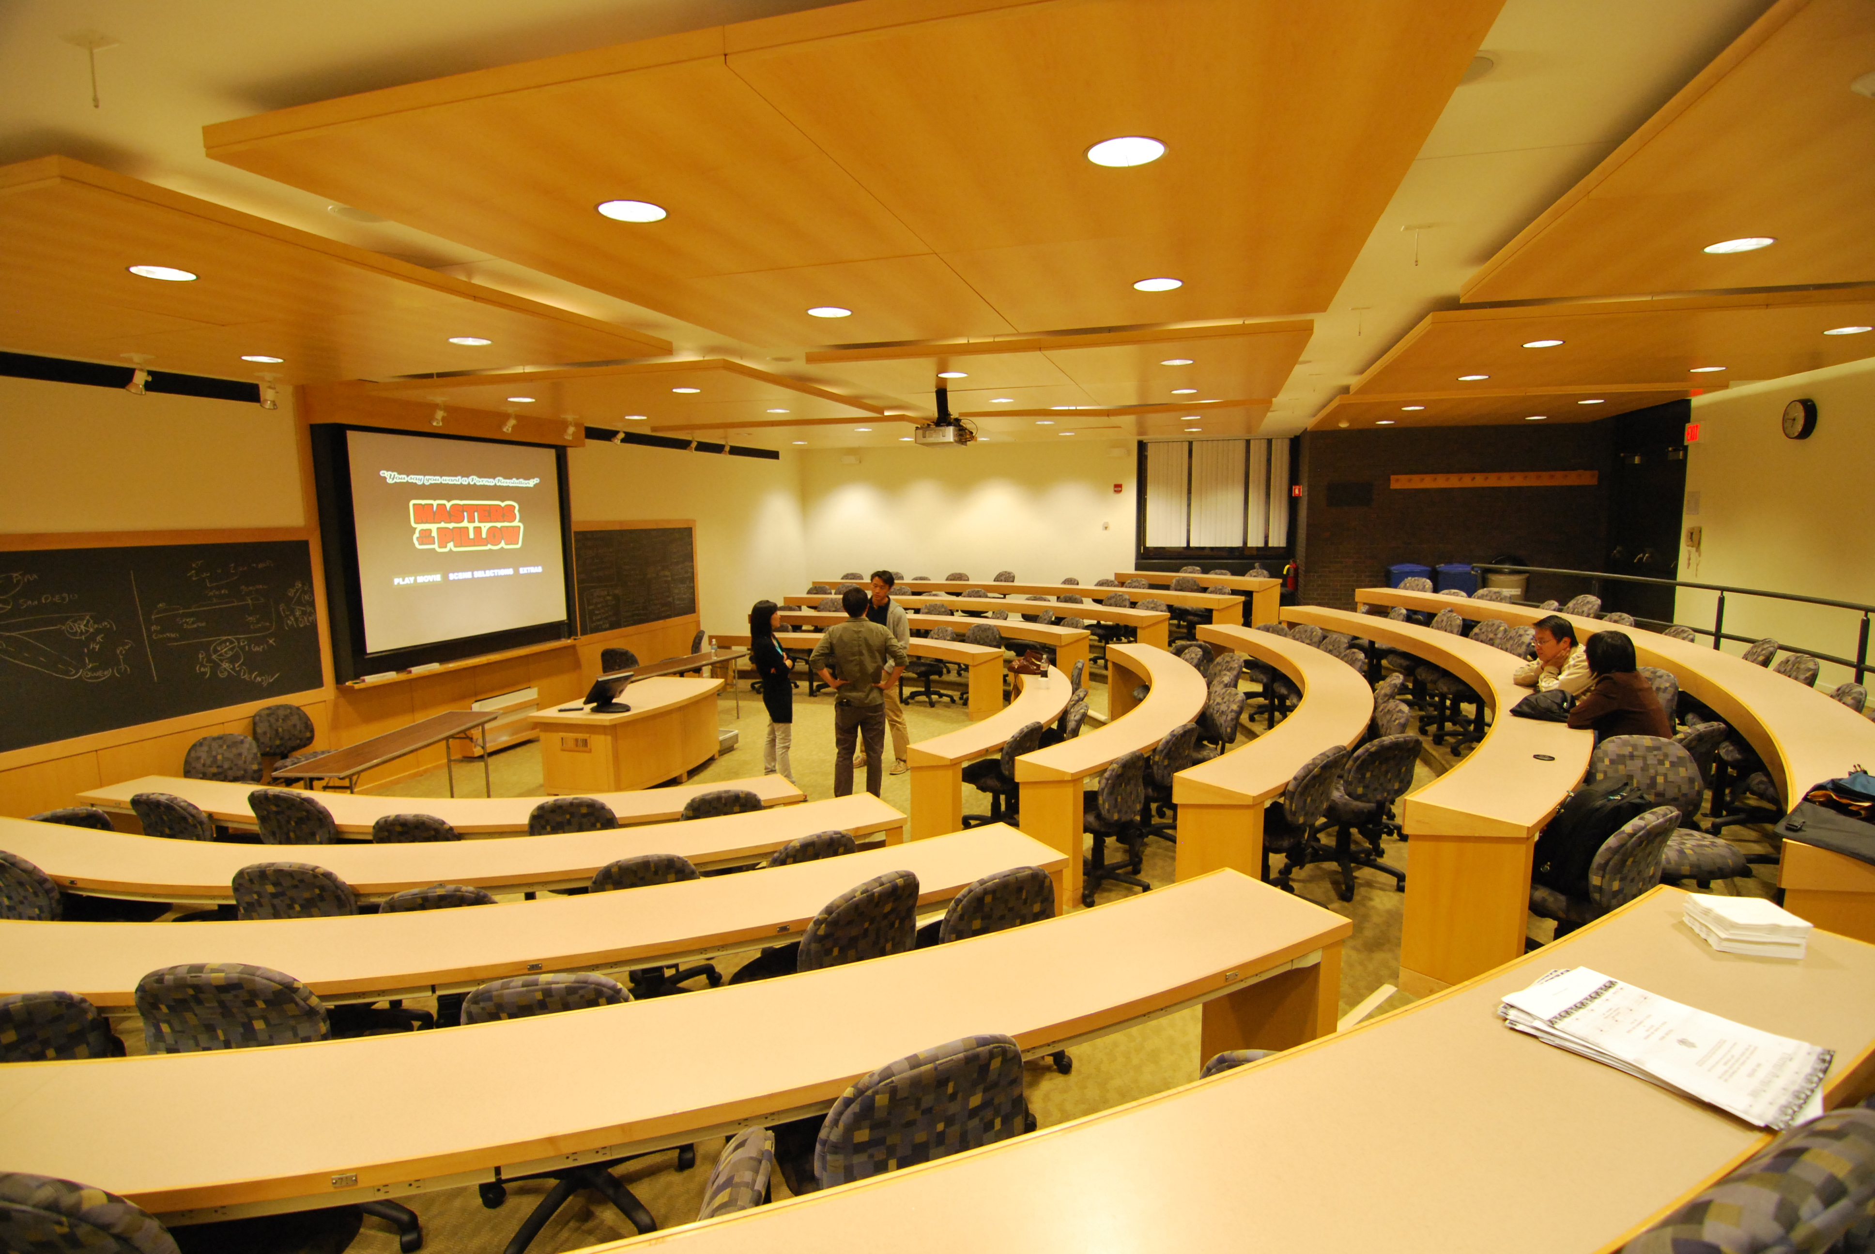 | Classroom Disruption:  Behavior that the professor views as substantially or repeatedly interfering with their ability to teach the class or the ability of other students to benefit from the instructional program is prohibited. The primary  responsibility for managing the classroom environment rests with the faculty. Students who engage in any acts that result in disruption of a class may be directed by the faculty member to leave the class for the remainder of the class period. If a student continues to engage in any acts that results in disruption of the class, the professor reserves the right to have the student removed from the course.  Academic Honesty:  Seeking, obtaining, or accessing information in any form or by any method other than the unprompted knowledge of the student constitutes cheating. Cheating on a test will result in loss of ALL credit for that test. Plagiarism is the presentation of work or ideas of another as one’s own. Plagiarism will result in loss of ALL credit for that paper. Repeated cheating and plagiarism will be referred to the Chair of the Department and the Dean of the School of Liberal Arts for additional review and disciplinary action.  Attendance, Participation, and Tardiness:  This course is primarily a lecture course; however, students are expected and encouraged to participate in class discussions. Roll will be taken at the beginning and end of each class. It is the responsibility of each student to sign the roll. This method of roll taking is utilized in order to eliminate disputes about actual attendance. Attendance is mandatory.  Cell Phones:  No cell phones are allowed in the classroom. No recording devices are allowed in the classroom. No devices with internet access are allowed in the classroom. If your cell phone goes off in class, you will be asked to leave.  Food in Class:  Please purchase all snacks before or after class. It is disruptive and disrespectful to the professor and fellow students to leave during class to visit the vending machines. Students are expected to clean up their surroundings before they leave the classroom.  Bathroom and Smoke Breaks:  Please use the restroom before or after class. It is disruptive and disrespectful to the professor and fellow students to leave during class. The University of Southern Indiana is a SMOKE FREE CAMPUS.  Class Withdrawal & Incomplete Policy  It is the student’s responsibility to officially drop/withdraw from any courses before the deadline. The university does not withdraw students from any classes. Please refer to the USI Academic Calendar (https://www.usi.edu/registrar/academic-calendar ) for specific dates. For more information, please visit http://www.usi.edu/registrar.
Technical Support Services:   | Since your professors are not trained as technology experts, they will not be able to assist you with your technical needs. Please contact the Help Desk at (812) 465-1080 or send an email to it@usi.edu for all your technical support needs. To learn more about the USI helpdesk, please visit http://www.usi.edu/distance/students/current/help-desk.
Tentative Topical Outline: | This is a tentative topical outline and may be changed at the discretion of the Professor with advanced notice.  All assignments for each week are due on the last day of the week/ Sunday.  It is the responsibility of student to check the discussion board for due dates.
Week 1  Monday, January 9th –  Sunday, January 15th | Chapter One:  Police Crime Control Strategy Development
Week 2  Monday, January 16th –  Sunday, January 22nd |   Martin Luther King Day, NO CLASS  Chapter Two:  The Police Effect on Crime
Week 3  Monday, January 23rd –  Sunday, January 29th | Chapter Three:  The Role of Community Policing
Week 4  Monday, January 30th –  Sunday, February 5th | Chapter Four:  Focusing Community Policing and Problem-Solving on Crime Reduction  Critical Book Review One Due
Week 5  Monday, February 6th –  Sunday, February 12th | Chapter Five:  A Typology of Crime Reduction Strategies
Week 6  Monday, February 13th –  Sunday, February 19th | Chapter Six:  Geographic Targeting Strategies
Week 7  Monday, February 20th –  Sunday, February 26th | Chapter Seven:  Offense Targeting Strategies
Week 8  Monday, February 27th –  Sunday, March 5th | Chapter Eight:  Offender Targeting Strategies  Mid-Term Exam
Week 9  Monday, March 6th –  Sunday, March 12th | Spring Break  
Week 10  Monday, March 13th –  Sunday, March 19th | Chapter Nine:  Compstat and Crime Control  Critical Book Review Two Due
Week 11  Monday, March 20th –  Sunday, March 26th | Chapter Ten:  Conducting Crime Strategy Meetings
Week 12  Monday, March 27th –  Sunday, April 2nd | Chapter Eleven:  The Resurrection of Sherlock Holmes
Week 13  Monday, April 3rd –  Sunday, April 9th | Chapter Twelve:  Staffing for Crime Control
Week 14  Monday, April 10th –  Sunday, April 16th | Chapter Thirteen:  Deployment for Crime Control
Week 15  Monday, April 17th –  Sunday, April 23rd | Chapter Fourteen:  Limitations on the Police Role  Critical Book Review Three Due
Week 16  Monday, April 24th –  Tuesday, April 25th | Chapter Fifteen  Evaluating Strategic Impact
Wednesday, April 26th   | Study Day No Classes
Final Comprehensive Exam | Thursday, April 27, 2017 –  Wednesday, May 3, 2017

